***CSC3610 Project Kick Off – October 8th Tuesday.***

***Project Topic Presentations.***

On Tuesday Oct 1, each group must present:

1. The name of their group – What should we all call you?
2. Who is on your team?
3. Their project Topic – What is the name of your project? Who is the customer? What are the key requirements?
4. The user(s) stories – See pdf example. The stories ***must*** describe the view point of all the users of the system.
   1. What are the needs of the key users
   2. How will you visualize what you are building to ensure it is correct?

Include on each story: a value statement, Acceptance Criterion and Definition

of done. <https://help.rallydev.com/writing-great-user-story> - good article

1. The trello board – Show the initial tasks you will start with. We will do 2 week sprints. <https://trello.com/wotakakajjumba/boards> You need to add me to your trello board.
   1. Describe the steps you need to complete in the next 2 weeks.
   2. Indicate who is doing what task.
2. What are the biggest obstacles you have at this point?

<https://help.rallydev.com/writing-great-user-story> - good article

Why Use User Stories?

* Keep yourself expressing business value
* Avoid introducing detail too early that would prevent design options and inappropriately lock developers into one solution
* Avoid the appearance of false completeness and clarity
* Get to small enough chunks that invite negotiation and movement in the backlog
* Leave the technical functions to the architect, developers, testers, and so on

Well-formed stories will meet the criteria of Bill Wake's INVEST acronym:

|  |  |
| --- | --- |
| Independent | We want to be able to develop in any sequence. |
| Negotiable | Avoid too much detail; keep them flexible so the team can adjust how much of the story to implement. |
| Valuable | Users or customers get some value from the story. |
| Estimatable | The team must be able to use them for planning. |
| Small | Large stories are harder to estimate and plan. By the time of iteration planning, the story should be able to be designed, coded, and tested within the iteration. |
| Testable | Document acceptance criteria, or the definition of done for the story, which lead to test cases. |

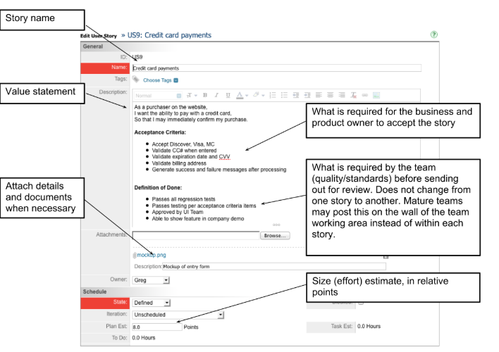

[https://www.promptworks.com/blog/what-makes-a-good-user-story-part-1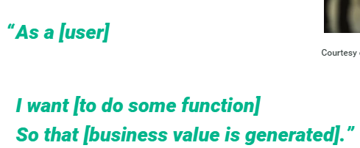](https://www.promptworks.com/blog/what-makes-a-good-user-story-part-1)

